Fashion circularity is now price competitive in the UK market
Netherlands-based Fibre to Fibre has expanded its operations to the UK, introducing its cost-effective circular textile solution to British fashion brands seeking sustainable alternatives. With an established customer base in Europe, the company has made the logical next step in order to further reduce textile waste.

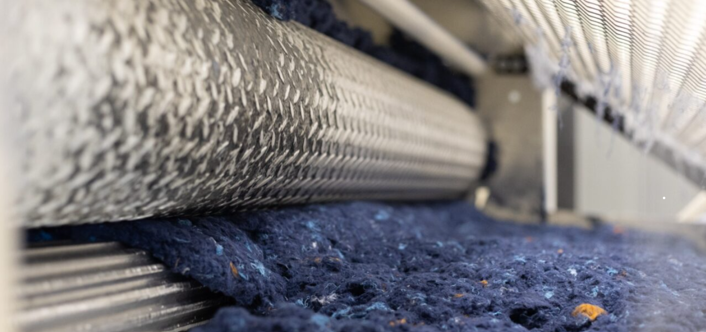

Advancing Sustainable Fashion Affordably
In a significant development for the UK fashion industry, a circular textile solution is now available with price points comparable to conventional materials without sacrificing quality. Fibre to Fibre's innovative process reclaims up to 60% of textile waste, converting it into new fibres in Europe that are then spun into circular yarns in Asia. They blend pre and post-consumer textiles with recycled polyester to create a 100% circular garment. This model of production enables the company to offer competitive pricing, effectively removing the cost concerns typically associated with sustainable options.
Combatting The Textile Waste Issue
As Fibre to Fibre scales operations in the UK, it strengthens its commitment to addressing textile waste issues in Europe. By fostering a closed-loop system, the company significantly contributes to reducing landfill contributions globally. They directly support the UK's circular economy objectives by fiberising the waste in Europe and only shipping raw material back to Asia for production.
"The move to circular textiles just became a level playing field in terms of cost" expressed Tom Atkin, head of UK business development for Fibre to Fibre. "Price competitive, quality-consistent circular materials are now available and are a no brainer for all brands."
The timing of Fibre to Fibre's market entry in the UK aligns with the increasing demand for environmental accountability and sustainable practices from fashion brands among consumers and regulatory entities. Fibre to Fibre's presence in the UK situates it perfectly to meet these rising demands while aiding the nation's shift towards more eco-friendly manufacturing techniques.

About: Fibre to Fibre
Fibre to Fibre is a leader in the circular economy, transforming discarded clothing into high-quality garments while eliminating waste exports. Based in the Netherlands, the company collects, sorts, and fiberizes textile waste, with usable fibers flowing into supply chains where they are spun into circular yarns. The company's mission is to make circular production the default by keeping textile waste in Europe for processing, reducing global landfill contributions, and pioneering solutions that redefine fashion manufacturing.

Newsroom
View the full press release including more photos and videos in our Newsroom.
View the full press release
View all previous press releases

Contact information
Name: Tom Atkin
Email: tom@fibretofibre.com
Phone number: +447772294348

