Fibre to Fibre bring post-consumer textile recycling to the UK market
Fibre to Fibre, a Netherlands-based textile recycling company, is extending its reach into the UK market, introducing a sustainable circular production model that repurposes discarded clothing into premium-quality garments. This expansion is timely, as UK fashion brands are increasingly urged to tackle textile waste, an issue highlighted by the estimated 1 million tonnes of clothing waste generated in the UK each year. Fibre to Fibre is committed to offering competitive pricing on par with organic cotton, striving to bring circular production within reach of mainstream fashion labels throughout the UK and Europe.

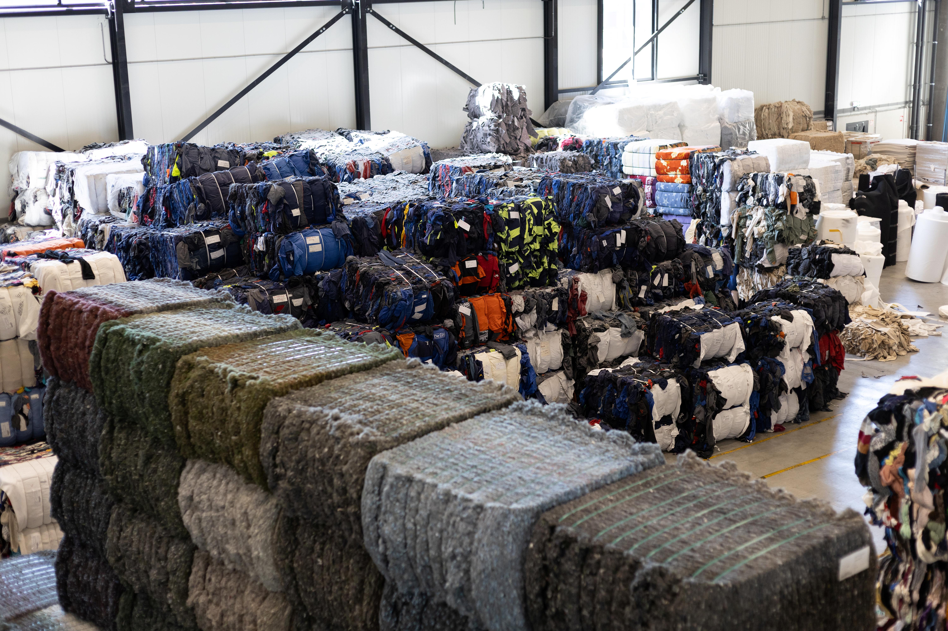

Keeping textile waste in Europe
Fibre to Fibre's entry into the UK market plugs a critical gap in domestic textile recycling infrastructure. They processes materials within Europe, collecting and sorting discarded garments before breaking them down into reusable fibers. Around 60% of processed materials are recovered and spun into circular yarns, combined with pre-consumer textiles, and recycled polyester.
"British fashion brands have been outspoken about their sustainability commitments, but the market has lacked practical ways to fulfill these goals," notes Tom Atkin, head of UK for Fibre to Fibre. "Our presence removes the logistical and financial barriers that have made circular production inaccessible for many companies so far."
Full-service or supply chain integration
Fibre to Fibre offers UK brands two collaborative models. Brands have the option of full-service support, which ranges from design to delivery, or they can choose to integrate directly into the supply chain at selected stages to align with their unique requirements. This versatility allows both emerging sustainable labels and well-established retailers to incorporate circular materials without the need to overhaul their current operations.
Sustainable fashion doesn't have to be expensive
In the past, recycled textiles have often been priced at a premium, discouraging broader adoption. Fibre to Fibre's competitive pricing model places circular yarns at rates comparable to those of organic cotton and recycled polyester, thereby
eliminating cost as a deterrent
. This approach debunks the myth that sustainable fashion must be expensive and may speed up the adoption of circular materials throughout the UK market.
This expansion comes at a time of increasing regulatory focus on the fashion industry's environmental footprint, with forthcoming extended producer responsibility legislation likely to transform textile waste management across the UK and Europe in the near future.

About: Fibre to Fibre
Fibre to Fibre is a Netherlands-based leader in the circular economy, transforming discarded clothing into high-quality garments while eliminating waste exports. The company collects, sorts, and fiberizes textile waste, with approximately 60% of usable fibers flowing into supply chains where they are spun into circular yarns. Its mission is to make circular production the default by keeping textile waste in Europe for processing and pioneering solutions that redefine fashion manufacturing.

Newsroom
View the full press release including more photos and videos in our Newsroom.
View the full press release
View all previous press releases

Contact information
Name: Tom Atkin
Email: tom@fibretofibre.com
Phone number: +310683603859

