Fibre to Fibre joins panel on circular fashion at Drapers summit
Tom Atkin, head of Fibre to Fibre UK, will present insights on circular production at the upcoming Drapers Conscious Fashion Summit in London on March 11. As part of a panel dedicated to designing for circular growth, Tom will discuss methods for integrating circular practices into high street brand manufacturing processes. This panel will unite industry frontrunners in discussing actionable approaches for achieving sustainable fashion on a larger scale.

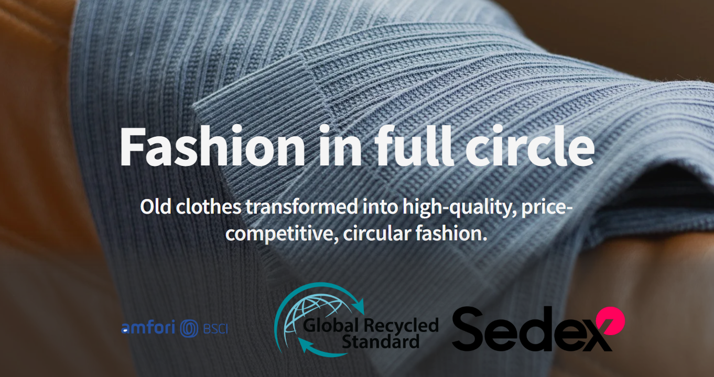

Making circularity accessible for mainstream fashion
The panel, "Designing for Circular Growth," will include insights from Bernice Pan of Deploy, Charlotte De Fraye of Have It Sust, and Rosamund Muir of Rosamund Muir London. While many discussions on circular fashion focus on design philosophy, Tom's input will emphasize the production infrastructure essential for circularity in brands operating at scale.
Fibre to Fibre processes textile waste in Europe, transforming discarded garments into new fibers that can be spun into yarn. Their approach maintains materials within the continental supply chain and prices circular yarns competitively with organic cotton and recycled polyester, tackling two critical barriers to mainstream adoption: logistics and cost.
From waste exports to European processing
"The fashion industry has often exported its waste problem, but we're demonstrating a more sustainable model," states Thijmen de Vries, spokesperson for Fibre to Fibre. "With circular materials as accessible and affordable as conventional options, brands can't claim sustainability is beyond their reach. Tom will discuss how this shift is occurring."
The Drapers Conscious Fashion Summit provides a stage for industry figures to delve into the convergence of commercial success and environmental stewardship. Atkin's participation marks a move in these talks towards tangible application, illustrating the integration of circular infrastructure into standard manufacturing processes.
Building supply chains that close the loop
Currently, about 60% of the textile waste Fibre to Fibre recovers returns to the supply chain as usable fiber, mixed with pre-consumer textiles and recycled polyester. Brands have the option to utilize the company's full-service model or integrate directly into the supply chain at their desired production phase. This versatility allows retailers of all sizes to engage in circular practices without a total operational makeover.

About: Fibre to Fibre
Fibre to Fibre transforms discarded clothing into high-quality garments through European-based collection, sorting, and fiberization processes. The company eliminates textile waste exports by keeping materials within Europe and producing circular yarns priced comparably to conventional sustainable options. Their mission is to make circular production the default in fashion manufacturing.

Newsroom
View the full press release including more photos and videos in our Newsroom.
View the full press release
View all previous press releases

Contact information
Name: Tom Atkin
Email: tom@fibretofibre.com
Phone number: +310683603859

