Fibre to Fibre makes source fashion debut with circular textile solutions
Circular economy leader Fibre to Fibre will make its debut at Source Fashion this January, demonstrating how textile waste can be upcycled into high-quality garments without prohibitive costs. Positioned adjacent to the VIP area, the company will offer interactive demonstrations on emissions reduction and feature a fibre bale exhibit to elucidate their closed-loop manufacturing process. Fashion brands interested in sustainable options are welcome to schedule meetings starting in mid-December to discuss supply chain integration.

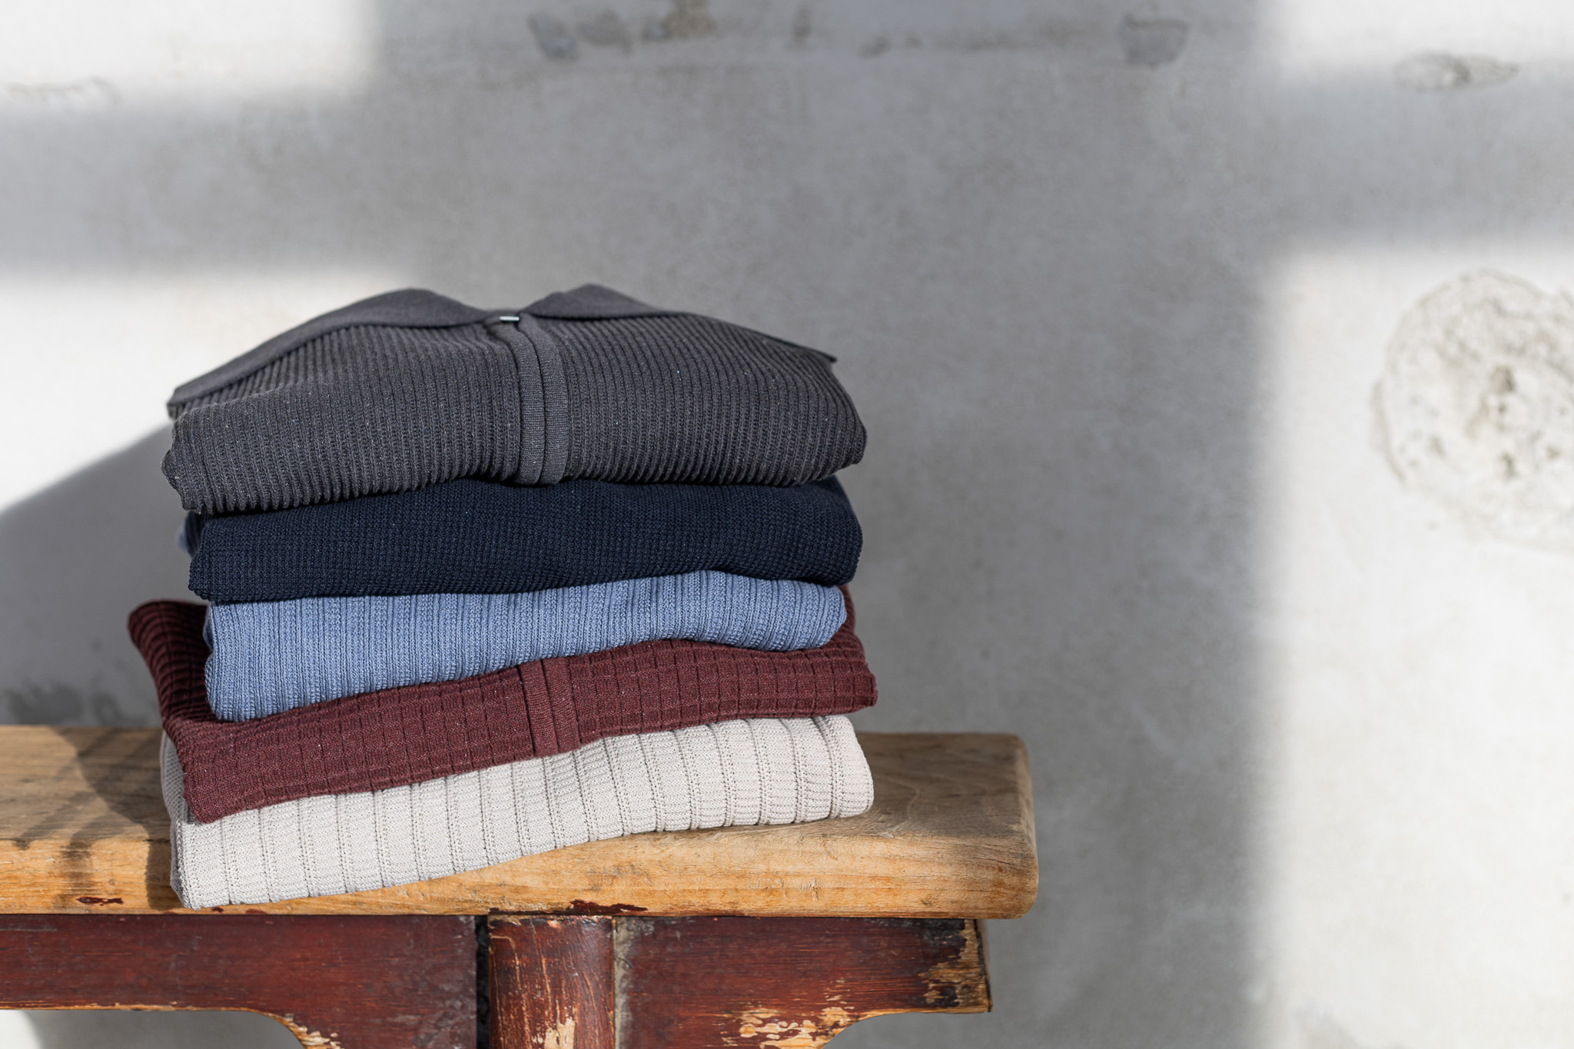

Closing the loop on textile waste
The exhibition arrives as the fashion industry faces increasing pressure to address its environmental footprint. Fibre to Fibre collects and processes discarded clothing in the Netherlands, transforming textile waste into fibers, and channeling approximately 60% of usable materials back into production. These recovered fibers are combined with pre-consumer textiles and recycled polyester to create circular yarns that are competitively priced with organic cotton and recycled polyester.
"We're leaving behind the time when sustainability was synonymous with a higher price tag," says Thijmen de Vries, spokesperson for Fibre to Fibre. "By processing textile waste within Europe and offering prices comparable to conventional sustainable materials, we're eliminating the economic barriers that have deterred brands from adopting circular practices."
Flexible integration for fashion brands
The company offers two collaborative models: a full-service option covering design through delivery, and supply chain integration where brands set their own parameters. This versatility enables fashion manufacturers to embrace circular production methods without restructuring their current operations. Partner companies will be at the Source Fashion booth to offer detailed insights into each stage of the transformation process.
Demonstrating emissions impact
Interactive demonstrations at the booth will quantify the emissions reductions achieved through circular textile production. The fiber bale display will provide visitors with a tangible view of the materials at an intermediate stage in the recycling process, showing how discarded garments become the raw materials for new clothing. By processing textile waste locally instead of exporting it, the company effectively addresses both landfill contributions and the carbon footprint associated with the global transportation of waste.

About: Fibre to Fibre
Fibre to Fibre transforms discarded clothing into high-quality garments while eliminating textile waste exports. Based in the Netherlands, the company collects, sorts, and fiberizes textile waste, channeling usable fibres into circular yarns combined with pre-consumer textiles and recycled polyester. By offering pricing comparable to organic cotton and recycled polyester, Fibre to Fibre aims to make circular production the default in fashion manufacturing.

Newsroom
View the full press release including more photos and videos in our Newsroom.
View the full press release
View all previous press releases

Contact information
Name: Tom Atkin
Email: tom@fibretofibre.com
Phone number: +310683603859

