Fibre to fibre to address circularity at Drapers summit
Tom Atkin, head of UK at Fibre to Fibre, is set to participate in a panel discussion on designing for circular growth at the Drapers Conscious Fashion Summit in London on March 11. This panel brings together leaders from across the value chain, from design and brand strategy through to fibre-to-fibre recycling, to examine the practical choices that enable (or prevent) circular outcomes in the real world. The discussion will also explore the growing trust gap in sustainability reporting. What data truly matters if brands want to demonstrate credible progress, and could independently verified, comparable performance become a genuine competitive advantage with consumers and buyers? Grounded in commercial reality, this session will give fashion leaders a clear view of what it takes to build circular models that can survive the market, not just the sustainability report. Joining Tom are founders from Deploy, Have It Sust, and Rosamund Muir London, who will share their expertise on the practical aspects of textile recycling and the implementation of circular manufacturing principles.

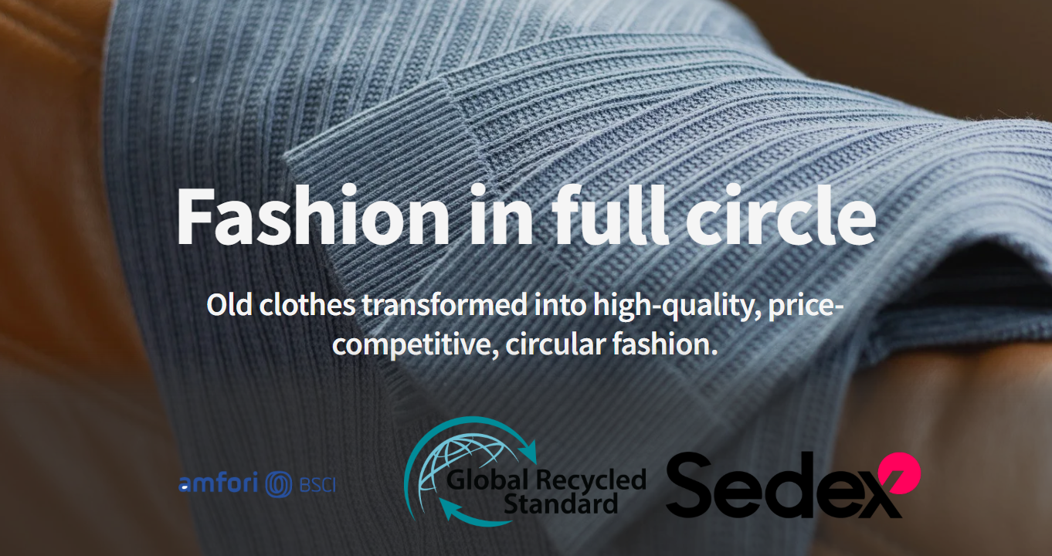

Bridging the gap between ambition and implementation
While numerous fashion brands have pledged to adopt sustainable practices, the shift towards circular production often falters at the implementation phase. In his panel contribution, Tom will unravel the technical and logistical complexities of integrating recycled textiles into mainstream fashion manufacturing. Drawing from Fibre to Fibre's experience with reprocessing post-consumer textile waste in Europe.
The panel comprises voices from diverse segments of the fashion value chain. Bernice Pan of Deploy, Charlotte De Fraye of Have It Sust, and Rosamund Muir will discuss design philosophy and brand strategy, while Tom will delve into supply chain incorporation and the practicality of manufacturing.
Making circular production accessible
"The dialogue around circular fashion has evolved beyond mere aspiration," notes Tom. "Brands are now seeking tangible routes to realization. Our competitive pricing, on par with organic cotton and recycled polyester, eliminates the financial obstacle that has traditionally hindered the broader adoption of sustainable systems."
Industry dialogue
The Drapers Conscious Fashion Summit creates a space for industry professionals to discuss the transformative challenges facing the sector. The day's sessions will cover a spectrum of topics in sustainable fashion, from material innovations to changes in business strategy. The circular growth panel is a highlight of the afternoon's proceedings and is available to all registered summit participants.

About: Fibre to Fibre
Fibre to Fibre transforms discarded clothing into high-quality garments while eliminating waste exports. Based in the Netherlands, the company collects, sorts, and fiberizes textile waste, with approximately 60% of usable fibers flowing into a circular supply chain where they are spun into yarns together with pre-consumer textiles and recycled polyester. Brands can work with Fibre to Fibre full-service or integrate the company's materials at their own specifications, with pricing comparable to organic cotton and recycled polyester.

Newsroom
View the full press release including more photos and videos in our Newsroom.
View the full press release
View all previous press releases

Contact information
Name: Tom Atkin
Email: tom@fibretofibre.com
Phone number: +310683603859

